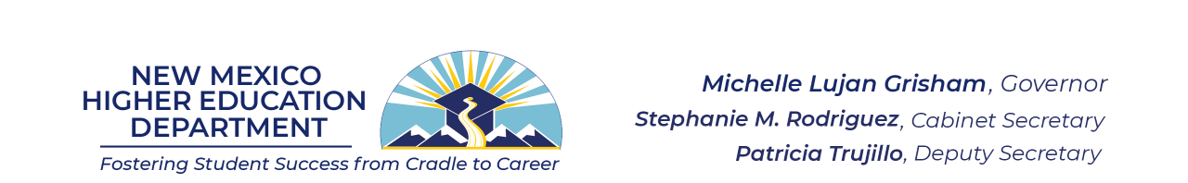

MEMORANDUM

TO: National External Diploma Program (NEDP) Local Provider Application
FROM: Amber Gallup Rodriguez, State Director of Adult Education Division
DATE: May 4, 2022
SUBJ: NEDP New Agency Application for Approval

The New Mexico Higher Education Department (NMHED) is working to implement the National External Diploma Program (NEDP) and is requesting applications from agencies interested in administering the program.
In program year 2022-2023, NMHED can provide financial support to a limited number of local programs in the first year of NEDP implementation, covering costs for training and implementation. In order to be considered for NMHED’s financial support in the 2022-2023 program year, you must submit the following application by June 3, 2022.
Selections will be made by a review committee and will be based on applicant agencies’:
- Knowledge about NEDP program requirements, as demonstrated by the application,
- Capacity to dedicate appropriate personnel to the NEDP program,
- Ability to commit to the training schedule, data collection, and all phases of the NEDP,
- Plans to sustain their provision of the NEDP over time, and
- A program’s location within the state, as NMHED seeks to build access over time to any eligible and interested New Mexican adult, including those in rural areas and those from marginalized populations.
If you have questions as you prepare this document, please contact NMHED AE at adult.education@state.nm.us or amy.anderson@state.nm.us.

National External Diploma Program (NEDP) New Program Application

PLEASE COMPLETE, SIGN AND RETURN NEW PROGRAM APPLICATION FORM
Scan and e-mail this form to: Adult.Education@state.nm.us with subject line “NEDP New Program Application” by June 3, 2022.

Program Name | Mailing Address |  |  | Phone
Program Contact’s Name | Program Contact’s Title |  |  | Program Contact’s Email
Program Mailing Address |  |  | Program County | Program Contact’s Phone
Secondary Contact Name | Secondary Contact Phone |  |  | Secondary Contact Email
PLEASE PROVIDE RESPONSES TO ALL THE FOLLOWING QUESTIONS.
Describe your knowledge about about the requirements for implementation and the time commitment - initial and ongoing - for NEDP training, specifically for the Advisor/Assessor and Portfolio Reviewer.
Describe how many FTEs and PTEs will be dedicated to the NEDP program?
How many staff will initially be trained and how will the roles of Advisor, Assessor, and Portfolio Reviewer be distributed? (A minimum of 2 trainees is required.) Please discuss these staff members’ qualifications.
If NEDP staff leave, what is your recruitment/replacement plan?
How will NEDP-related data be collected and by whom?
How will NEDP staff members be compensated for their responsibilities?
If your program is funded in program year 2022-2023, most of the first year’s NEDP costs to your program will be covered by NMHED. However, in future years, you may need to contribute funds to sustain the program. What funding might you use, and is funding for a single year or multiple years? Describe how your program will be sustainable over time and a worthwhile investment of state funds in this first year.

Are you currently an adult education provider?

Does your agency have sufficient technology to support virtual advising and communication with clients?

Whom will the program serve, and which localities will be served?

How will staff stay in touch with clients who are in the program?

How will new clients be identified?
About how many clients will be in the initial cohort? How many clients does the program hope to serve in the first year?

What is the plan for the program’s NEDP growth? What outreach strategies will the program use to let the public know about the program?

Since NEDP is not an instructional program, what resources will be available for NEDP clients needing instructional support?

How will the program leverage regional resources, and how will the program establish sustained relationships with local employers and workforce development agencies to promote NEDP?

NAME, TITLE, AND SIGNATURE OF INDIVIDUAL COMPLETING THIS APPLICATION.

Name (Print): |  | Title:
Signature: |  | Date:

